# EULER’S CONSTANT

Based on compound interest.

Suppose a bank pays you annual interest of 100% on $1, n is the number of payments per year

n =1,

Suppose they paid you 50%, every 6 month instead

Suppose the bank paid you per week

Suppose the bank payed you per day

Suppose the bank paid you hour second

Where

Replace with π with x:

Let x =i π:

= -1

## TAYLOR SERIES

Also *e* can be described by the infinite series:

Approximation Error

+…..

This follows the polynomial:

* Where a = 0 we have the *McLaren Series*
* Where a >0 we have the *Taylor Series*
* We can use the Taylor Series to solve non-linear equations where solutions are impossible or difficult to solve and arrive at approximation to solutions.

Example:

f(a) = y(0)

we know y(0)= -1 and

since x = 0

for Next co-efficient

since

then )

) add initial conditions

)

if x= 0.5

then y(0.5) ≈ 0.68

Example 2:

Example 3:

## CHARACTERISTICS OF

# LOGARITMS

### LOGARITMIC GRAPHS

Semi-Log Graphs

Value of *y = 10nx + N0*

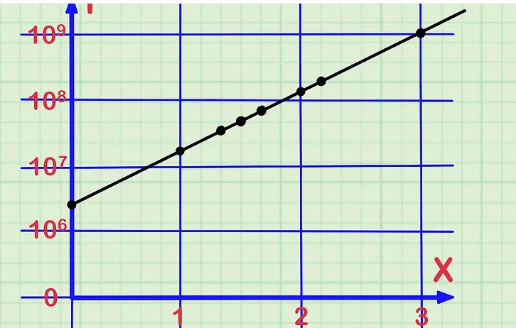

x-axis scale.

The x-axis is the independent variable. The independent variable is the one that you generally control in a measurement or experiment. The independent variable is not affected by the other variable in the study. Some examples of independent variables may be such things as: Date, Time, Age, Medication given

**logarithmic scale for the y-axis**.

You will use a logarithmic scale to graph data that changes extremely quickly. A standard graph is useful for data that grows or decreases at a linear rate. A logarithmic graph is for data that changes at an exponential rate. Samples of such data might be: Population growth rates, Product consumption rates Compounding interest

# MATRICIES

Matrix: is an array of numbers or functions

## MULTIPLICATION

C

Match

(m x n) * (n x p)

Answer

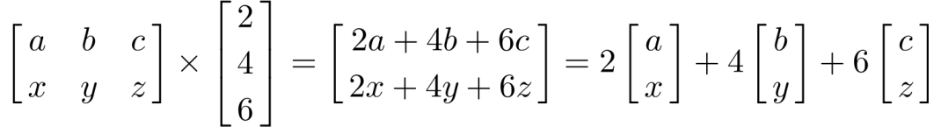

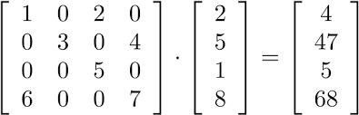

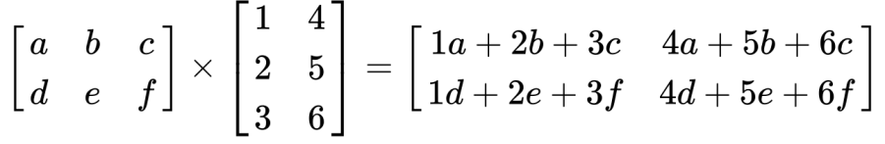

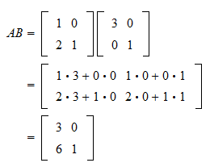

## APPLICATION - SIMULTANEOUS EQUATIONS

*Solve for x, y and z : 2x + y – z = 1*

*3x + 4y + 2z =13*

*x – 5y – 2z = 0*

*62z =248*

*z=4*

*y=-1*

*x=3*

*Ans: (x,y,z) = (3, -1, 4)*

*Solve for x, y and z: x + y +2z =-2*

*2x - y + 14z =6*

*x +2y = -5*

*let z = t t2*

*x=1 - 4t*

*y =2t -3*

*t is a variable can represent any value ie the solution is a set of lines set of lines y –x =2t -3 -4t*

*y= x-2t -3*

*Ans: No solution*

# LOG GRAPH APPLICATIONS

1. pH (the measure of a substance 's acidity or alkalinity), volume inceases expontentialy
2. decibels Units of Amplitude the measure of sound intensity …..intensity and power: intensity is proportional to the square of the amplitud Relation between Loudness and Amplitude: Loudness is directly proportional to square of the amplitude. Example: When a body vibrates with a greater amplitude, it sends forth a greater amount of energy and hence the energy received by the eardrum is large, so the sound appears louder Db is the x-axis

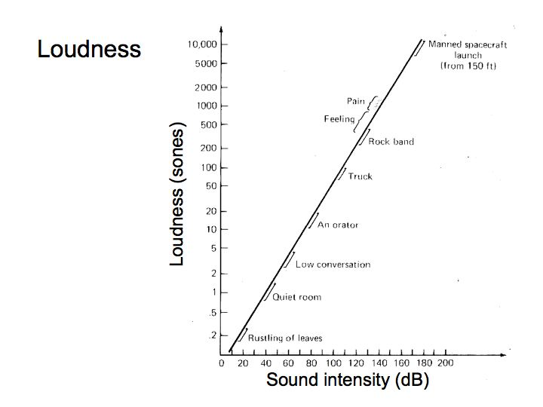

The Richter scale is used to rate the magnitude of an earthquake -- the amount of energy it released. The Richter scale is logarithmic, meaning that whole-number jumps indicate a tenfold increase. In this case, the increase is in wave amplitude.

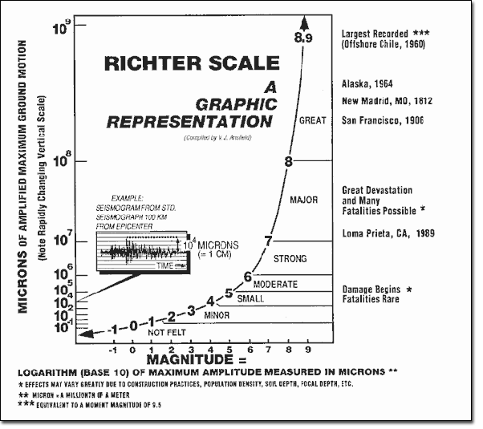

1. pH of 7 is neutral. A pH less than 7 is acidic. A pH greater than 7 is basic. The pH scale is logarithmic and as a result, each whole pH value below 7 is ten times more acidic than the next higher value.

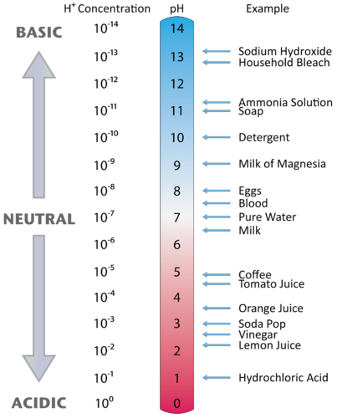

The pH scale is used to rank solutions in terms of how acidic or how basic they are. It indicates the concentration of hydrogen ions (H+) and hydroxide ions (OH-) in a solution. These ion concentrations are equal in pure water, which has a pH of 7

The higher the H+ concentration, the lower the pH, and the higher the OH- concentration, the higher the pH. At a neutral pH of 7 (pure water), the concentration of both H+ ions and OH- ions is 10⁻⁷ M. ... Due to this influence, H+ and OH- are related to the basic definitions of acids and bases.

# APPLIED STATISTICS

Data Set: array or database

Data types:

* + - 1. Numerical
         1. discrete
         2. continuous
      2. Categorical:
         1. Nominal: no order or hierarchy cannot be measured against each other, e.g. Colours
         2. Ordinal: same as categorical but can be measured against each other e.g., school grades as letters

Example 1 : What position does Steph Curry Play in the NBA?

*Ordinal data : sample set = {guard, forward, central}*

Example 2: What team does Steph Curry play for in the NBA?

*Nominal data: sample set = {Atlanta Hawks, Boston Celtics……..}*

Example 2: What is Steph Curry’s 3 point percentage this season ?

*Each 3 point attempt provides nominal data i.e. success/fail. Numerical summary is continuous Stats are 0.4766 (continuous) of 128 shots (nominal)*

## STATISTIC TERMINOLOGY & PYTHON NUMPY’S FUNCTIONS

|  |  |  |  |  |
| --- | --- | --- | --- | --- |
|  |  |  |  | Sample Values |
| 1 | *µ* | mean() | Average value | *x* |
| 2 |  | median() | Mid-point value |  |
| 3 |  | mode() | Most common value |  |
| 4 | *σ* | Standard deviation std() | How spread out are the values. Low *σ,* numbers are close together. If mean = 77.4 and *σ* = 37.8then values are with 37.8 from the mean of 77. | *s* |
| 5 | *σ 2* | Variance var() |  |  |
| 6 |  | Percentile | Number that describes the value that a gen percentage of values are lower than. I.e. 75 percentile is 43. Means 75% of people are younger than 43 |  |
|  | π | Proportion | Of categorical variable | *p* |
| 7 | *p* | Correlation | Between 2 variables | *r* |
| *8* | *ß* | Gradient | Between 2 variables | *b* |
| *9* | *θ* | General usage |  |  |

## NORMAL DISTRIBUTION

The heights of players are normally distributed. Probability Density Function (PDF) describes:

1. The whole population of player heights, and
2. The probability of selecting one player at random from the population at every given height

Mode ()

Freq.()

7ft3 (tallest player)

Height (ft)

5ft9 (shortest player)

## SAMPLING DISTRIBUTIONS

If we were to select 10 players, what would be the probability distribution of their average height?

n=1

n=10

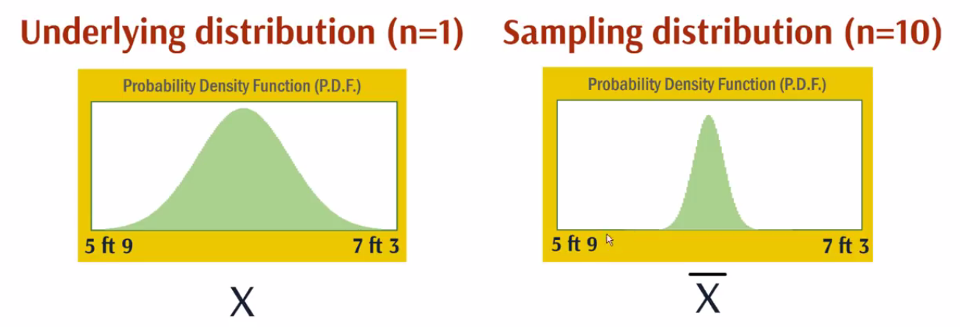

ANS: the larger the sample the less likely to get extreme values ie the Variance (*σ 2* ) is reduced

How good is Steph Curry currently at 3 pointers?

Steph Curry: 61/128 shots = 0.47766 vs Mayers Leonard 9/15 = 0.6000

Sample size *S = 128 S = 15*

*θ1 = 0.47766* = parameter **estimate** of how good he *θ2 = 0.6000*

Measured with 95% confidence interval (v1-v2)

*σ 12*

*σ 22*

v1 *θ1* v2

v3 *θ2* v4

*θ1* and *θ1*  are estimates and we are 95% confident that they lie between values *v1 -v2* and v3-v4 respectively.

*Variances σ 12 = (v1 - v2) and σ 22 =(v1 - v2)*

Because *θ1*has a larger sample space, then *σ1 2 < σ2 2.* increased variance = increased uncertainty to stay within the 95% confidence level.

## HYPOTHESIS TESTING

Is there enough evidence that Meyers Leonard is shooting above 60%.

*Set H0* : *θ ≤ 0.5* (Null hypothesis) worst case scenario

*H1* : *θ>0.5* (Alternate hypothesis) seeking evidence for this - may be true

Binomial Distribution:

Assuming he is a 50% (which is the Null hypothesis) shooter and shot

9/15, it seems possible and highly probable (p =0.10)

12/15 it seems more improbable (p<0.04)

*p=0.340 (our sample)*

*p ≤ 0.05:* Rejection Region - Reject H if scores > *12* or *more* (usually set at 5% of entire distribution = level of significance)

The Hypothesis Test checks how extreme our hypothesis *H* is.

If Ho is > 12 ( greater than 5% of the total distribution) then we consider it too extreme and therefore reject it.

**Ans: We cannot reject H0 but there is not enough evidence to infer H1**

Working on probability we can never ‘prove’ or ‘accept’ anything, we can only ‘reject’ and ‘infer’ referring to evidence.

### P- VALUES

1. Hypothesis test assesses if your sample is extreme enough to reject the Null hypothesis
2. P-value measures how extreme our sample is. Our p-value says our sample is in the top 30.4% of the distribution ( p=0.340)
3. If p>0.05 and is rejected does not mean the hypothesis is false. It means that we got a freak sample i.e. ***possible but highly improbable.***

### RESEARCH & P-VALUES

1. Start with probability density function. Start with H0 = no effect
2. Take a sample that is extreme enough to reject the H1 i.e. construct rejection region
3. If p>0.05 and is rejected does not mean the hypothesis is false. It means that we got a freak sample i.e. ***possible but highly improbable.***

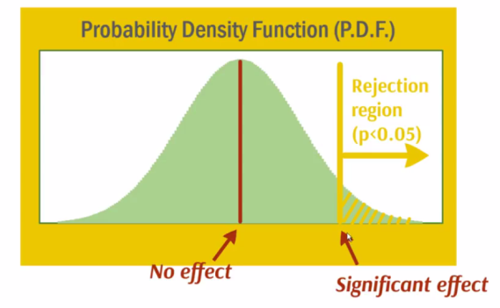

1. Theorise an effect eg Red wine causes cancer
2. Collect data
3. Test that effect and only that effect
4. If p<0.05 conclude there is strong evidence for the effect eg red wine on cancer

Bad research – p- hacking

1. Collect data on possible causes of the effect. Ie various causes of cancer. Eg lifestylex environmental exposure.
2. Test all the causes. Find causes where p<0.05
3. Conclude strong evidence for the effects

Problem:

1. Low p-value suggests:
   1. strong evidence for the effect of cause and,
   2. there is low probability hat this correlation came about by chance.
2. It we test *x* >1 different causes, the can there is
   1. increased the probability that **any** one cause results in an effect.
   2. One cause will become extreme is their sampling randomness
   3. Inscreased Probability expecting Any one cause can have a value p<0.05
   4. Nullifies results

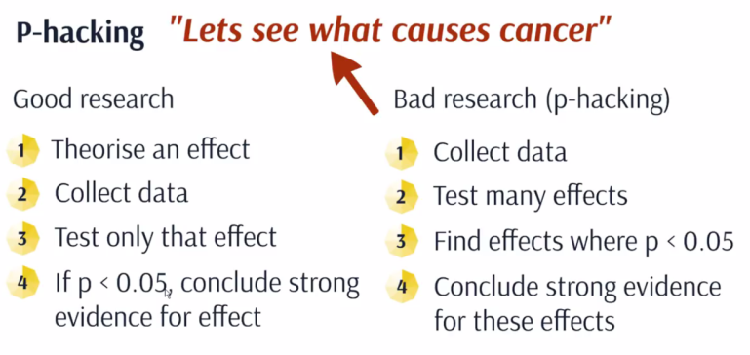

Low probability for change

Test 20 things , 1 things out of 20 will likely have a p<0.05.

Bad research (p-hacking)

Collect data

Test all effects

Find effects p<0.05

1. If p<0.05 conclude there is strong evidence for the effect

# PROBABILITY DISTRIBUTION MODELS

All random variables have distributions

1. Continuous (measurable) distributions:
   1. Normal
   2. Uniform
   3. Triangular
2. Discrete (countable) distributions:
   1. Binomial
   2. Poisson

1 Weekly Ice-cream Sales Analysis

Example:

|  |  |  |
| --- | --- | --- |
| ***Individual Sales***  ***(No of ice-creams)*** | ***Customers (No)*** | ***Relative Frequency***  ***P(X=x)*** |
| 1 | 225 | 0.45 |
| 2 | 170 | 0.34 |
| 3 | 55 | 0.11 |
| 4 | 20 | 0.04 |
| 5 | 20 | 0.04 |
| 6 | 10 | 0.02 |
|  | **500** | **1.00** |

What is the probability that a person buys more than 3 icecreams

*P(X>3) = P(X=4) + P(X=5) + P(X=6)*

*= 0.04 +0.04+0.02 = 0.01 = 10%*

## NORMAL DISTRIBUTIONS

Each normal distribution is defined by N(*σ, µ),* its Mean and Standard Deviation.

* *σ* = the Median
* 68.2% of all observations fall within 1 *σ* of the *µ*
* 99.5% of all observations fall within 2 *σ* of the *µ*
* 99.72% of all observations fall within 3 *σ* of the *µ*
* When z = 1.96, equivalent to 95% of all observations
* When z = 2.58, equivalent to 99% of all observations

## PROBABILITY DENSITY FUNCTIONS (PDF)

Area under graph represents the probability.

# POPULATION GROWTH MODELS

Let the population of an area = N. The population growth rate can be described by the equation:

N(t)

N

0

*t*

N

0

t

## THE LOGISTIC CURVE

This curve indicates that a population will grow at an exponential rate indefinitely. This is not realistic. We therefore need a limiting factor, *k* and let the starting population be N0

N

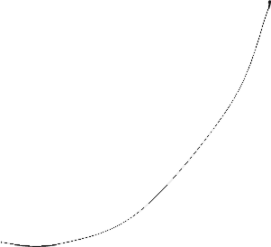

Levelling off

Inflection point

Exponential curve

*N0*

*k*

N

*N(t)*



*t*

0

t

Similarly

If Using the *Bifurcation* Formula

Using Geogebra graphing software tool

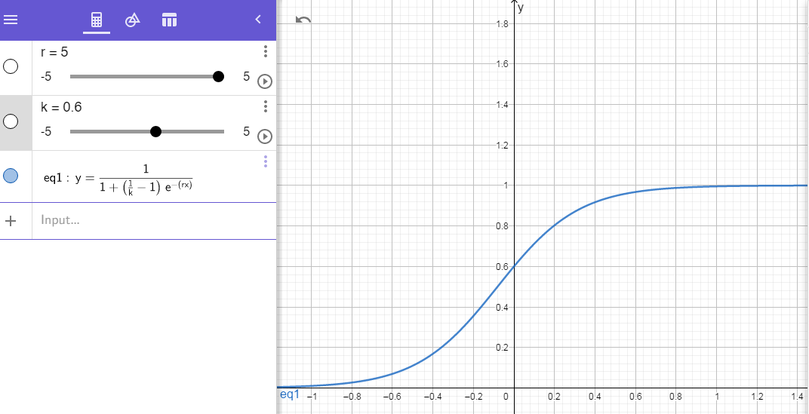

## MODELLING IN PYTHON

A chaotic dynamical system is highly sensitive to initial conditions; small perturbations at any given time yield completely different trajectories. The trajectories of a chaotic system tend to have complex and unpredictable behaviour.

Many real-world phenomena are chaotic, particularly those that involve nonlinear interactions among many agents (complex systems). Examples can be found in meteorology, economics, biology, and other disciplines.

the logistic map is an archetypal example of how chaos can arise from a very simple nonlinear equation. The logistic map models the evolution of a population, taking into account both reproduction and density-dependent mortality (starvation).

We can draw the system's **bifurcation diagram**, which shows the possible long-term behaviour (equilibria, fixed points, periodic orbits, and chaotic trajectories) as a function of the system's parameter.

We can compute an approximation of the system's **Lyapunov exponent,** characterizing the model's sensitivity to initial conditions.

Function in Python:

def logistic(r, x):

return r * x * (1 - x)

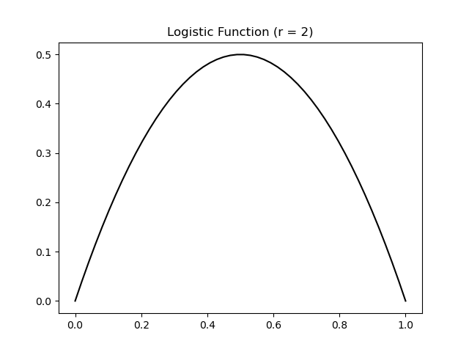

A few iterations of this system with two different values of *r*

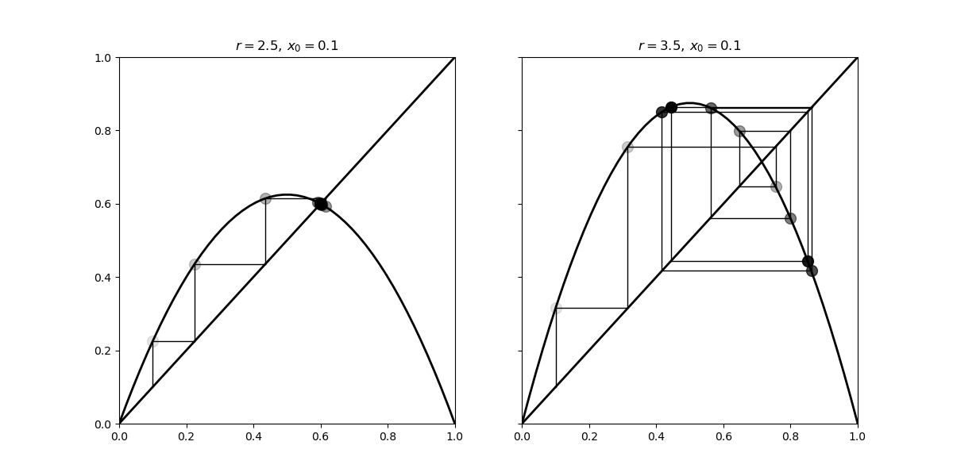

In the left panel, we can see that our system converges to the intersection point of the curve and the diagonal line (fixed point). On the right panel however, using a different value for *r*, we observe a seemingly chaotic behaviour of the system.

5. Now, we simulate this system for 10000 values of *r* linearly spaced between 2.5 and 4, and vectorize the simulation with NumPy by considering a vector of independent systems (one dynamical system per parameter value):

n = 10000

r = np.linspace(2.5, 4.0, n)

6. We use 1000 iterations of the logistic map and keep the last 100 iterations to display the bifurcation diagram:

iterations = 1000

last = 100

7. We initialize our system with the same initial condition r

x = 1e-5 * np.ones(n)

8. We also compute an approximation of the Lyapunov exponent for every value of [Math Processing Error]. The Lyapunov exponent is defined by:

We first initialize the lyapunov vector:

lyapunov = np.zeros(n)

The bifurcation diagram brings out the existence of a fixed point for *r<3*, then two and four equilibria, and a chaotic behaviour when *r* belongs to certain areas of the parameter space.

We observe an important property of the Lyapunov exponent: it is positive when the system is chaotic (in red here).

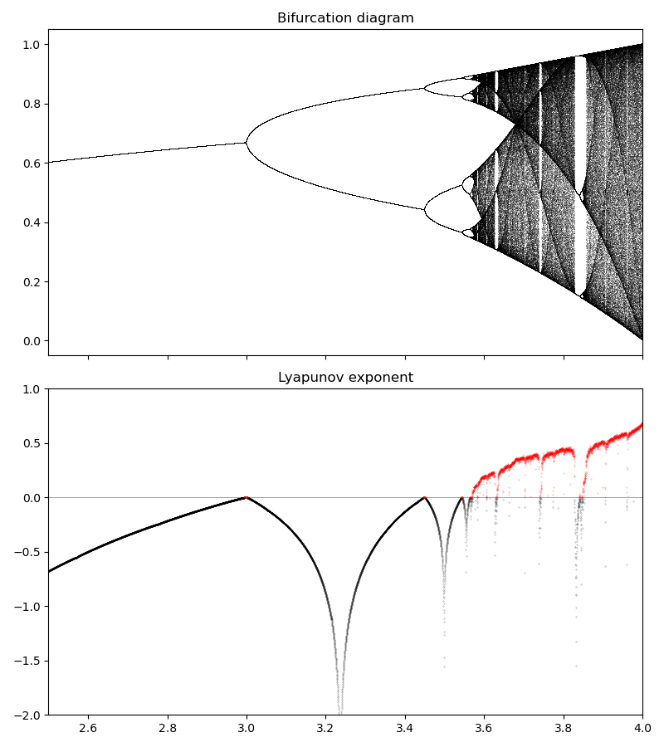

## APPLICATION – SPREAD OF COVID-19

Let Nd = the number of cases on a given day

E = average number of people someone infected is exposed to each day

P = the probability of each exposure becoming an infection

Then *Nd = E * P * Nd =EPNd*

*Nd+1=Nd +EPNd = (1+EP)Nd*

**(1+EP) is the critical factor great changes in the outcome of N. i.e. reduce the number of exposures.**

Growth factor >1 N(t) is below inflection point. I.e. infection rate increasing

Growth factor <1 N(t) is above inflection point. Rate is decreasing

### SIR Model

Susceptible = S(t) as a function of time, t

Infected = I(t)

Recovered = R(t)

Where *a, b* and *c,*  are contestants

# CHAOS THEORY

## CHAOS SETS

## MENDLEBROT SET:

Is a set of complex numbers that satisfy the above equation for which the function remains bound within (+2, -2 and 2*i*, *-2i* ).

Ie replace C with a complex number and iterate accordingly

For C = 1

C = 1 is unbound so is not part of the set. Colour this point black.

for C = -1

C = -1 is bound so is part of the set. Colour it according to it’s ????

## JULIA SETS

Replace z0 with a complex number e.g. z = 0.3 +0.1i

Choose a value of C e.g. c = 0.4 + 0.325i

Iterate for values z1, z2, z3,

Graph patterns / shapes will vary accounting to the values of C

## FRACTALS

Fractals describe Self Similarity and repetition at smaller and smaller scales

## APPLICATION - CHAOTIC BEHAVIOUR OF SYSTEMS

Chaotic systems display sensitive dependence on initial conditions

Small changes in initial conditions, deliver unexpected, divergent behaviour in results and an unprintable final state. Reason: negative feedback loops.

# QUANTUM MECHANICS

Electrons are waves described by the Schrödinger’s equation

## QUANTUM FIELD THEORY

Empty space in a vacuum is empty on average. Energy is borrowed from the future to form a particle and anti-particle, which self-destruct instantaneously. Called virtual particles

Empty space contains highly entangled fields and energy inversely proportional to its entanglement.

Space

Fields Energy

## STANDARD MODEL

4 elementary particles with each its corresponding field:

1. Electron
2. Up-quark
3. Down-quark
4. Neutrino

These are duplicated but heavier , so we have 12 particles that are more exotic

4 forces with each its corresponding field

1. Strong Nuclear Force
2. Weak nuclear Force
3. Gravity : which is space & time itself
4. Electromagnetic Force

Total = 16 fields

Higgs Field responsible for mass

Total = 17 particles & fields

However, theory cannot explain

1. Dark Energy
2. Dark Matter
3. Inflation of the universe

FEINMAN DIAGAMMES

*t*

*e-*

*e-*

ṻ1

ῡ1

*ieγµ*

*ieγµ*

*ieγµ*

v1

u1

*e-*

*e-*

*Space (x)*

# RELATIVITY

## SPECIAL RELATIVITY

X=0,t=max; standing still

r2 = x2 + t2 – circle is an inaccurate description

r2 = x2 - t2 – hyperbola is accurate

Time (t)

r2

t=0,x=max; maximum speed

Space (x)

1. All objects are constantly moving through Space –Time at one speed – the speed of light.
2. When an object moves faster, time slows down. When it approaches the speed of light, the clock almost stops.
3. Therefore the speed of light is the fastest an object can move through space

## GENERAL RELATIVITY

1. Laws of physics are the same in all inertial frames of reference
2. The speed of light is constant for all observers – time dilation
3. Gravity stretches, bends, manipulates space-time
4. Equivalence Principal - Gravity is equivalent to acceleration
5. Space-time tells matter how to move and matter tells space-time how to curve
6. Light waves bend around massive object